**SRS**

**Emergency Help Service**

**Problem Statement :**

So, working on the above line of thought, we are building a web-App which can help people to report their emergencies with provided sections can contact their nearby help centres for type of emergency and can directly report to them with single SOS Button click with user location and emergency contact numbers. User can directly send message to their trusted emergency numbers too by single SOS Button click and adding personalised message for the same.

**Requirements Collection Phase:**

**Functional requirements:-**

* Registration with the email id or mobile number
* User Verification by mobile number
* Reliability
* Fast Response
* Simple User interface
* On-Tap Solution in case of emergencies.
* Basic information to get registered such as name, contact no, gender,DOB.
* Trusted contacts and their contact numbers.
* Login Services on app.
* Emergency according affiliated control room and other authority details.
* Confirmation message with ticket number of emergency
* Location Services.
* Trusted Contact Notification System.
* Blogs for different Emergencies.
* Message and notification services.
* Live Heat map Generation.
* Database Maintenance.
* Small App Size.

**Non-Functional requirements :-**

* **Accessibility** : Any body possessing a smartphone and net connection has access to the website and app.
* **Privacy :** Authorities can only know the name, phone number for contact and location. Other private information of the user is not shared on public data.

**Background readings:**

We have analyzed several websites and services that provide solutions to emergency services. Some of them are listed below with their specialities we have thought to include in our solution.

●  [https://www.ready.go](https://www.ready.gov/)

* We have analysed this website as precaution of emergency service so users can get to know about techniques and steps to do before emergency occurs and can get ready for emergency and be a hero of society when emergency happens. We will be providing different types of disasters and emergency with precaution of that emergency so that user can be ready for any kind of emergency.

● <https://www.911.gov/>

* It provides all services under 911. User can contact server room by calling or texting on this number so basically we have used different contact numbers with different locations and type of emergencies.

● <http://www.ses.sa.gov.au/site/home.jsp>

* Services provided on this website is all about giving warnings by online server to users. People can see current disasters and where they are happening and how to make distance between that.

● <http://www.ndma.gov.in/en/>

* It contains whole database of India’s state wise and city wise contact numbers of different affiliated ministry and control room numbers so user can contact directly to that.

● <https://www.emergencyreporting.com/>

* This organization provides online and offline services on different type of emergencies so that they can help different organizations where risk is high.

● <https://play.google.com/store/apps/details?id=com.emergencyreporting.InspectER&hl=en>

* Android app that can report emergencies with minimal cost and sync data with database . user can capture photos while reporting complaint. 24x7 location services so that in case of emergency affiliated control room can track the location.

● <https://play.google.com/store/apps/details?id=dev.en.yobuyo.basic&hl=en>

* Single Tap Panic Button !! In case of emergency that you don’t have a time to report things you can just press that button and control room will track you and contact you.

● <https://play.google.com/store/apps/details?id=com.threesixtyentertainment.nesn>

* Location wise report your emergency and contact control room by call or message.

**Questionnaires:**

We have made list of questions so that we can see the user requirements and work accordingly on our solutions as features desired for users will be given priorities and their approach to our solution is core input for us.

**1.Do you have a smartphone?**

1. Yes
2. No

**2. Please select your age group**

1. Below 18 yrs
2. 18- 25 yrs
3. 25-40 yrs
4. Above 40 yrs

**3. Which type of service you are comfortable with emergency help service application?**

1. Emergency call
2. Message

**4. Which type of emergency you face more often?**

1. Earthquakes
2. Floods
3. Accidents
4. Robbery
5. Fire

**5. How many apps you have currently installed on phone that you don’t use on daily basis?**

1. 0
2. 1 – 5
3. 5 – 15
4. 20+

**6. How many applications do you have on your mobile phone?**

1. 0
2. 1 – 5
3. 5 – 15
4. 20+

**7. What do you prefer to use when using Internet on your smartphone?**

1. Web application
2. Android application
3. No preference

**8. Why do you use more web browsers rather than applications?**

*(Several answers possible)*

*For the Respondent - The different possible answer choices are presented in **random order**.

|  |
| --- |
| 1. More used to it (from experience with computers) 2. Because the application related to the website I want to visit doesn’t exist or I cannot find it. 3. I don’t want to install applications for random use. 4. The applications from some websites are not functional, don’t work well. 5. Usually I search for a general term, rather than needing a specific application. 6. Other, please specify: |

**9. Why do you use more applications rather than web browsers?**

1. Better use, tailored to mobile phone
2. It is faster (Internet Speed)
3. It is easier to find, straight on my main screen, application list

|  |
| --- |
|  |

.

**10. Would you use minimal size app which cost ~ 5 MB on your phone which you can’t use on daily basis ?**

1. Strongly agree
2. agree
3. neutral
4. disagree
5. strongly disagree

**11. Will you use website if you are in case if emergency ?**

1. Strongly agree
2. agree
3. neutral
4. disagree
5. strongly disagree

**12. Describe if you were in any emergency before and need of any king of specific service so that we can consider that as user requirement.**

Paragraph Answer :

**Survey summary :**

We have circulated Google form to DA-IICT students via WebMail and forwarded to our friends directly by whatsapp and other social medias so from 1500+ people whom we have circulated our form we got 50 responses. With these 50 responses of user and their requirements in case of emergency we have updated our plan of action towards our project. We have asked a dilemma questions like emergency call or emergency text message or notification. Even we have asked that will they install our application as it’s not a daily usage app. After survey we have got some of the clear results which includes Pi-Charts of our questionnaires so major dilemma questions with their results are listed below,

* We have seen that most of the users have smart-phone and ready to use application as our service.

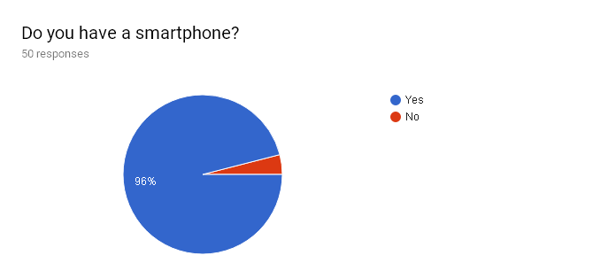

* We have analyzed age-group of our users and their requirements and young people below 25 years are ready to use our application as a service.

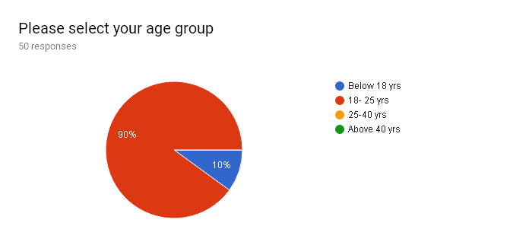

* We have asked users to choose between emergency call, emergency message and notification and the answer is 98% towards emergency call as no one trust on messages in case of emergencies.

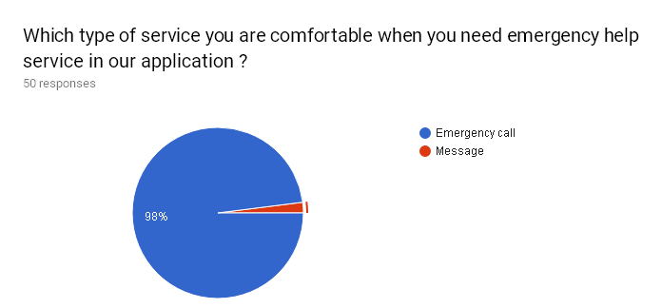

* We have listed different type of emergencies and analized which emergencies are more often users face off so that we can focus more on that.

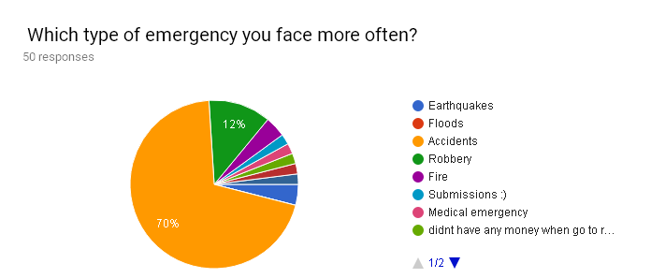

* We have done general analysis so that we can predict that will user install our app in his/her phone by his/her phone’s current application count status.

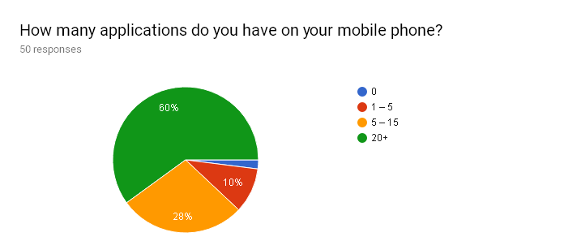

* As per developing non-daily base app we have to consider this point as major affliction as our services are not in use if user won’t take our app installed in his/her phone for long time.

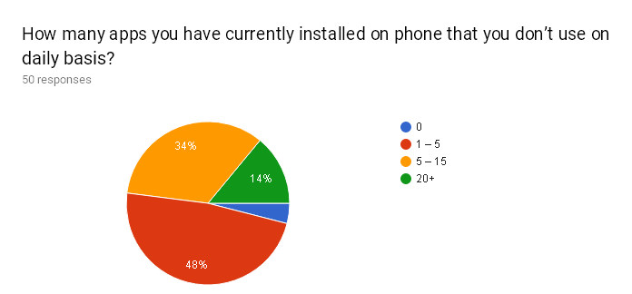

* 74% people suggested us to make Android application. One reason of that could be Android application is more easy to find from the mobile’s installed application than website because users have to search and find appropriate website from the search results. So we are now more focusing on Android App rather than web app.

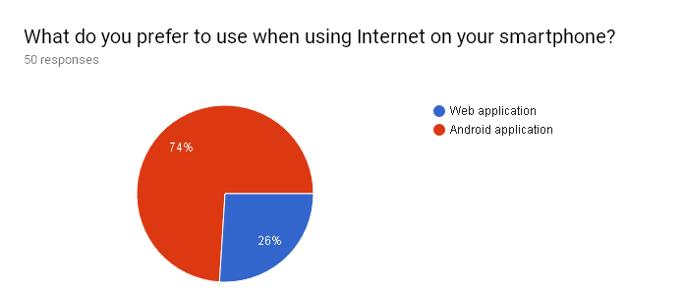

* The responders who suggested us to make Android application we also asked them why android application is more useful than websites. Most of the users says that it’s easier to find from application list.

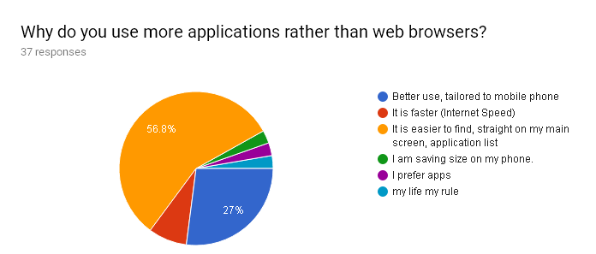

* As per user requirements we have just asked users that will you use website in any case with scalar option and we have analyzed that 30+ people would not like to use our service as website so it’s more preferable for us to switch on Android.

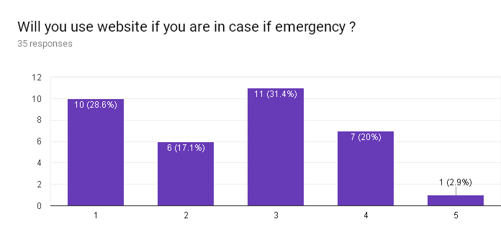

* We want to analyze reason behind people who were ready to use website was they are more regular to web-apps and can use that but will they use website in case of emergencies too is not sure as already in above question majority haven’t agreed with website.

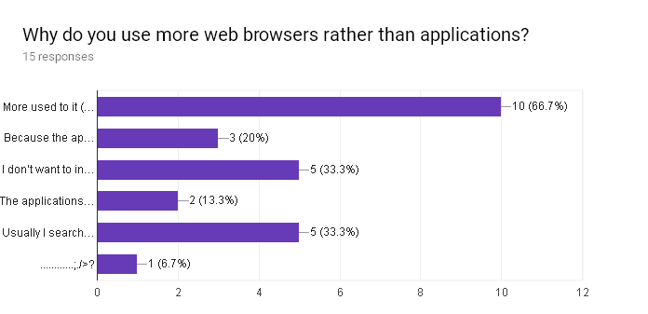

* We are concerning number of features here and we got to know that people want simple GUI and quick response app rather than full-fledged app so we are focusing on small size app for now.

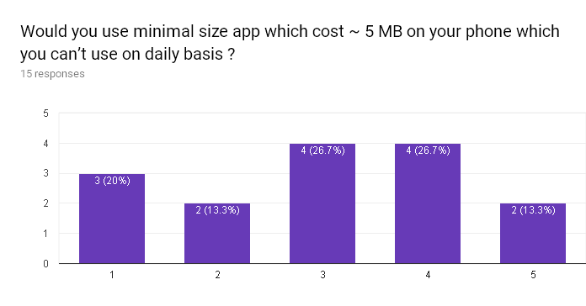

**Interview:**

**purpose of interview:**

We are going to conduct interview of victims of emergencies so that we can analyze the situation of every second of emergency if he/she was unable to use our service at time of emergency our services doesn't matter for them so we have to keep time to report emergencies as minimal as possible and have to give more and more features at that time so we have to build optimal solution sos that users can be conveyed by our services .

**Agenda:**

What kind of emergency he/she was in and what he's he has done at that time. How can we improve facilities to them as we have to see user requirement and aspects to us from user’s point of view.

**Interview summary 1:**

Participants: Priyank Prajapati (system developer)

Ramanbhai Prajapati (policeman)

Date: 20/01/2018 Time : 14:30

Duration : 45 minutes Place: Raman Prajapati’s Home

Contact : 9879356677

Purpose of Interview :

Preliminary meeting to identify problems and requirements regarding security at the Season’s Flavour site.

* Documents to be brought to the interview :
  + Statistics of google form

**Interview Summary**

* According to him, our app will be useful because when they get call from people aboutcrimes or for help, it’s little bit hard for them to find the perfect location. If our application provide them a perfect location of victim then it’s more useful to them.
* As per him we should focus more on women-safety features in our application.
* As per him good UI is important as even government apps have failed due to bad UI.
* As per him we should provide as simple interface for policeman too as they are not going to invest on any system for our services.
* According to him call is the best option in case of policeman as Indian government couldn’t is not that technically advanced that they can track each victim as per their technical support services.
* They have asked us to maintain fake complaints by filtering out with some ideal tricks and also provide online register for non-emergency types complaints.

**Interview summary 2:**

Participants: Meet Shah (system developer)

Dimple Shah (User)

Date: 20/01/2018 Time : 14:30

Duration : 45 minutes Place: Dimple Shah’s Home

Contact : 9998619238

Purpose of Interview :

Preliminary meeting to identify problems and requirements regarding

security at the Season’s Flavour site.

* Documents to be brought to the interview :
  + Statistics of google form

**Interview Summary**

* According to him, he uses most of the famous android apps in his phone but though less android apps which he can’t use on daily basis.
* He suggested us to make a minimal size app with compact features so he can keep it installed on phone.
* He suggested us to make a simple UI and call facilities from app.
* He asked us to provide UI which can lead user to appropriate contact number with type of emergency.
* He asked us to store all information and make a statistics of complaints.
* At last he was happy with our efforts and as a active android user he suggested us some apps to make similar UI so that it can be more user-friendly according to him.

**Fact finding chart:**

|  |  |  |  |
| --- | --- | --- | --- |
| **Objective** | **Technique** | **Subject** | **Time commit** |
| To get background reading of the our problem statement and objectives. | Background reading | Articles, available Web Services and Mobile Services. | 2 day |
| To gain the knowledge of each type of emergency and Authority Response techniques. | Interview | Authority Interview | 1 Hr. |
| To gain knowledge of User Requirements and User expectations from our Services. | Interview | User Interview | 1 Hr. |
| Survey of users | Questionnaires | User Requirement Analysis | 4 Days |
| To follow up development of Emergency service requirements | Observation | Technical Mandatory Requirements | 1 Day |

**User categories:**

* Everyone who can access smart phones/computer can use this service.

**privileges :**

* Every user has android app installed or signed up on website to get services in case of emergency.
* For those who just want to contact their trusted contacts will be given another mode of emergency where authorities will not be interrupted.
* User can select type of authority but can’t delete or add any data available on application or website.
* Authority can delete live emergencies from database and remove from heat map.

**Assumptions:**

* We assume that admin and the users are able to use the application properly.
* People will use our application because we think it's a good application.
* They have access to the internet.
* The admin can know the location of user by location of user’s device or by contacting the user.